## Blank Canvas

Selecting the **blank canvas** option will provide you with a plain canvas to draw your plan on.

**To create a Blank Canvas Plan:**

* Select **New Plan Wizard** in the Quick Start section of the Welcome to RapidPlan page.
* In **step 1**, select **Blank Canvas**.
* In **step 2** enter your plan’s details and choose a print region and scale if needed.
* In this step, if you scroll down you can also add a **job location** to make the plan searchable by location.
* Once you are ready, select **Create Plan** in the top right of the window.
* 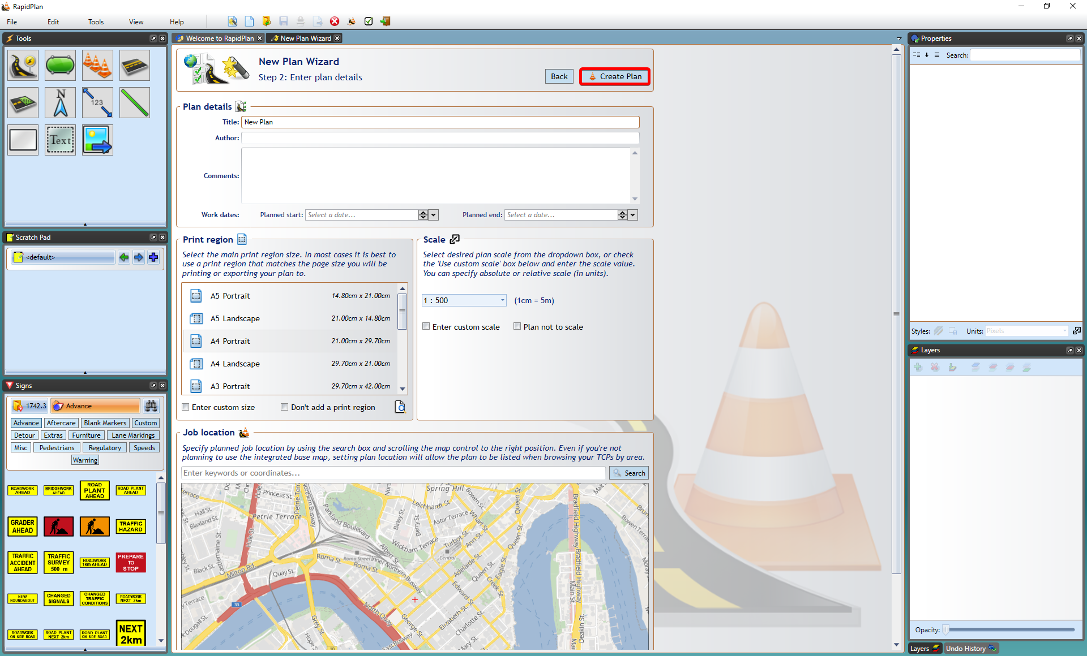
* Enter_Plan_Details
* **Note**: Selecting a job location with this plan type only makes it searchable by location, if you want to use the integrated mapping feature, see **Base Map** below.